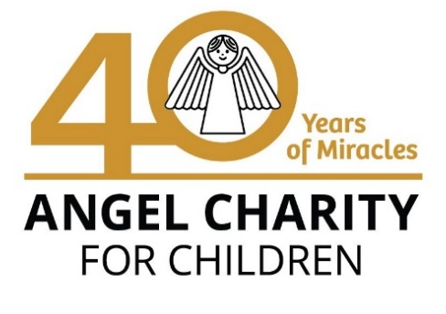
3132 N. Swan Rd. • Tucson AZ 85712 • 520-326-3686 • AngelCharity.org •

May 2022

Dear Friend:

I appreciate your support of Angel Charity and our mission to improve the quality of life for children in Pima County. For 40 years, Angel Charity has raised over $29 million to benefit more than one million children. With your help, we are committed to honoring our mission because our children need us now more than ever. Purchasing Chance Tickets helps Angel Charity reach our fundraising goal. For only $100 you can help children in Pima County and have a chance to win 4, $10,000 cash prizes!

This year, we have committed to fundraising $1,426,200 benefitting our 2022 beneficiaries:

Youth On Their Own (YOTO): $750,000 To fund renovation of its new headquarters to ensure their location is safe for youth and enables the expanded delivery of their mission to help youth experiencing homelessness to stay in school and graduate.

National Alliance on Mental Illness (NAMI) Southern Arizona: $388,000 To help support the Ending the Silence program for middle and high school students to learn about mental illness and make a meaningful difference in the mental health of our youth.

Small Grant Beneficiaries:
Boys to Men Tucson, $77,900
El Rio Health Center Foundation, $50,000
Junior Achievement of Arizona, $50,000
Nourish, $25,000
TMC Foundation, $50,300
Tucson Girls Chorus, $10,000
YWCA Southern Arizona, $25,000

Angel Charity has an important role to play by continuing to serve the children in our community. Will you join us?

Purchase Chance Raffle Tickets
$100 per ticket for a chance to win one of four $10,000 cash prizes
Drawing will be December 10th, 2022
Order online at AngelChanceTickets.org

Sincerely,

YOUR NAME HERE
PHONE NUMBER or EMAIL

