3132 N. SWAN RD. ∙ TUCSON, ARIZONA 85712 ∙ 520-326-3686 ∙ ANGELCHARITY.ORG
2024 Executive  Committee  General Chair  Kellie Terhune Neely  Vice Chair  Dawn Darling  Capital Campaign/  Underwriting  Tana Lopez  Founding Chair  Guardian Angel Emeritus Louise Thomas  Guardian Angels  Cheryl Cox  Adaline Klemmedson  Vickie Butler  Chair Elect  Vicky Curtis  Recording Secretary  Christine Turner  Treasurer  Gracie Marum-Quiroz  Parliamentarian/MAL  Laura Buckelew  Angel Ball Chair  Nanci Berens  2023 General Chair  Jeannie Nguyen  Events Chair  Betty Jo Weaver  Communications Chair  Valerie Fanelli  Solicitations Chair  Mary Coelet  Operations Chair  Cathy Solverson  Membership Liaison  Paige Cogdall  Board of Directors  Jeanne Silverberg  Shelene Taylor  Karla Looby  Kelly Medvec  Ariana Cornidez  Veronica McCuthcheon  Jennifer Nyman  Melissa Gibbons  Anna Martinez-Ross  Misty Arnold  Dorene Nichel  Jill Brooks  Cindy Robertson  Lia Keller | Month 00, 2024  Name(s)  Street  City, ST ZIP  D Dear FORMAL Name(S),  On behalf of Angel Charity for Children and our 2024 beneficiaries, we thank you for your support and generous donation of $XX,XXX, on Month 00, 2024. As we celebrate our 42nd year of raising funds to benefit the underserved children in our community, it is your kindness that continues to help meet the various needs of the many children’s services in Pima County.  Angel Charity has a proud history of advancing its mission to improve the quality of life for children  in our community. We are grateful that you have chosen to partner with us once again. 100% of the  donations go directly to our capital campaign to our beneficiaries.  NAME(S), we know that you have many charitable options from which to choose. We are grateful to you for selecting Angel Charity for Children as a recipient of your kindness and generosity. Certainly few investments could be more significant than those made on behalf of a child.  Thank you for helping Angels Work Miracles®.  With Gratitude,  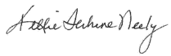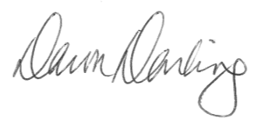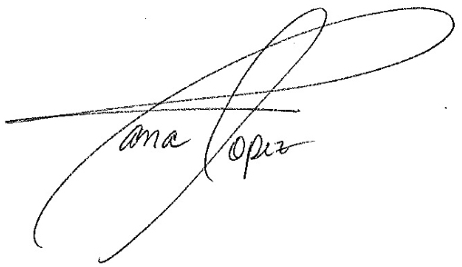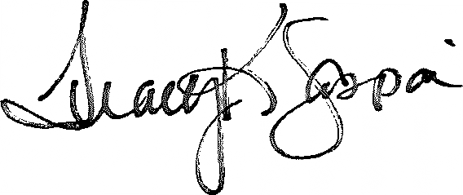  Kellie Terhune Neely Dawn Darling Tana Lopez Tracy Gaspari  2024 General Chair 2023 Vice Chair 2024 CCU Chair 2024 CCU Coordinator

