3132 N. Swan Rd. ∙ Tucson AZ 85712 ∙ 520-326-3686 ∙ AngelCharity.org
2024 Executive  Committee  General Chair  Kellie Terhune Neely  Vice Chair  Dawn Darling  Capital Campaign/  Underwriting  Tana Lopez  Founding Chair  Guardian Angel Emeritus Louise Thomas  Active Guardian Angels Cheryl Cox  Adaline Klemmedson  Vickie Butler  Chair Elect  Vicky Curtis  2023 General Chair  Jeannie Nguyen  Angel Ball Chair  Nanci Berens  Communications Chair  Valerie Fanelli  Events Chair  Betty Jo Weaver  Membership Liaison  Paige Cogdall  Operations Chair  Cathy Solverson  Parliamentarian/MAL  Laura Buckelew  Recording Secretary  Christine Turner  Solicitations Chair  Mary Coelet  Treasurer  Gracie Quiroz Marum  Board of Directors  Misty Arnold  Jill Brooks  Ariana Cornidez  Melissa Gibbons  Lia Keller  Karla Looby  Anna Martinez-Ross  Veronica McCutcheon  Kelly Medvec  Dorene Niichel  Jennifer Nyman  Krystal Popov  Cindy Robertson  Elisa Ross  Jeanne Silverberg  Kristie Stevens  Shelene Taylor | <DATE>  <DONOR NAME>  <BUSINESS NAME>  <ADDRESS>  <CITY, STATE ZIP>  Dear <INSERT DONOR NAME>,  Angel Charity for Children is celebrating 42 years of making miracles happen for the children of Pima County, Arizona. We thank you for your continued support of our mission. Since 1983, we have funded more than $31 million for 137 project request grants, impacting over one million children. With your help, we are committed to honoring the needs of our children now more than ever. We are so excited to have you partner with us to raise funds for our 2024 beneficiaries.  Angel Charity has committed to fund $1,313,100 to seven local non-profit organizations in 2024.  Impact Grant Beneficiary:  Children’s Museum Tucson - $1 million to renovate the new Education Center and create additional program spaces and expand access for kids from Title I schools, reaching an additional 40,000 students in the first year.  Opportunity Grant Beneficiaries:  Arizona’s Children Association - $75,000  Fox Tucson Theatre Foundation - $32,500  Junior League of Tucson - $67,600  TMC Foundation - $65,000  Tucson Community Tennis Program - $52,000  Wheel Fun - $21,000  Angel Charity has an important role to play by continuing to serve the children in our community. Will you please join us? We have enclosed our CCU form and Community Impact Brochure to give you more information. We would love the opportunity to talk to you about Angel Charity and our deserving beneficiaries. Please contact Tana Lopez at angelcharitytana@gmail.com or by calling 520-730-4545. Your support will make the difference in the life of a child and significantly impact the future of our community. Thank you for your thoughtful consideration.  Sincerely,  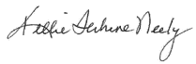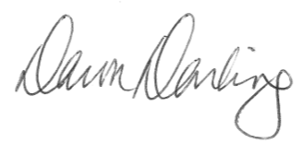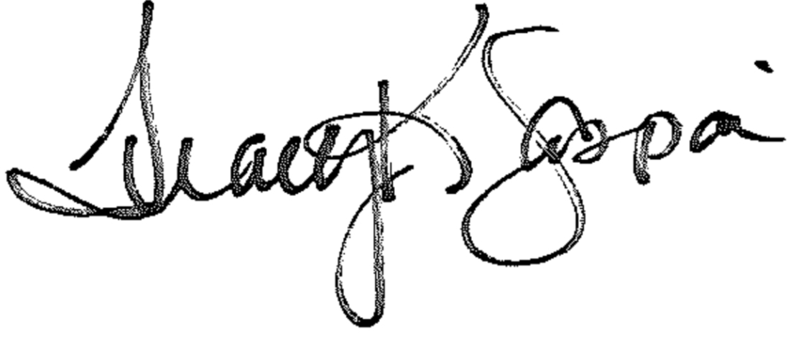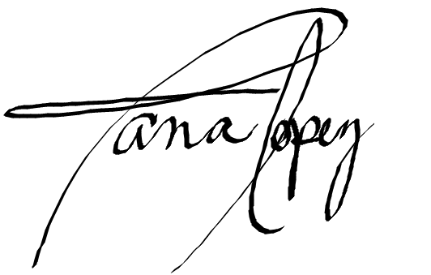  Kellie Terhune Neely  2024 General Chair  Dawn Darling  2024 Vice Chair  Tana Lopez  2024 Capital Campaign & Underwriting Chair  Tracy Gaspari  2024 Capital Campaign & Underwriting Coordinator  Erin Vincent  2024 Triple Halo  Chair

