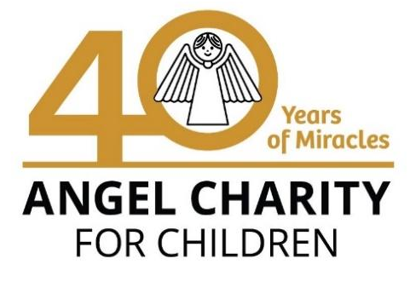
3132 N. Swan Rd. ∙ Tucson AZ 85712 ∙ 520-326-3686 ∙ AngelCharity.org ∙

Dear XX,

Angel Charity for Children, Inc. has raised over $29 million to fund more than 90 different local children’s organizations. These dollars have been used to construct new buildings, renovate and expand old ones, fund scientific research, retire mortgages and support much-needed programs. More than one million children have benefited from the services that Angel Charity and its donors have funded over the years.

On behalf of Angel Charity for Children, Inc. I would like to ask for your support. It would be an honor to partner with you to improve the lives of children in our community. It is our hope that you are able to donate a gift item or a gift certificate to Angel Charity for use at our Angel Ball on December 10, 2022.

This year Angel Charity has committed to grant $1,426,200 for nine beneficiaries including:
-Youth On Their Own (YOTO): $750,000 to fund renovation of its new headquarters. This will ensure their location is safe for youth and will enable them to expand delivery of their mission, which is to help youth experiencing homelessness to stay in school and graduate.
- National Alliance on Mental Illness (NAMI) Southern Arizona: $388,000 to help support the Ending the Silence program for middle and high school students. It will teach them about mental illness and make a meaningful difference in the mental health of our youth.
-Boys to Men Tucson: $77,900 to support a Healthy Intergenerational Masculinity Initiative. They will provide weekly group mentorship circles, led by adult male mentors, and allow at-risk boys to genuinely express themselves and share their hopes and struggles. It will serve 700 boys at 25 middle and high schools and community centers, improving their chances to succeed, and making our community safer.
- El Rio Health Center Foundation: $50,000 to help launch a new Youth Mental Health Pilot Program at Tucson’s largest provider of health services. The pandemic has escalated the need for behavioral mental health services for youth suffering from anxiety, depression, and behavior problems. The program will serve 200-300 youth ages 12-18 who lack resources to obtain treatment elsewhere.
- Junior Achievement Southern Arizona: $50,000 to expand the JA Anywhere program to reach 1,400 low income, diverse students in kindergarten through 12th grade and prepare them to succeed in work and life. The program will equip them with the knowledge and skills they need to manage their money, plan for their future, and make smart academic, career and economic choices.
- Nourish: $25,000 to provide therapy and dietician services to young children with feeding challenges caused by medical problems such as prematurity, heart issues, autism, gastrointestinal difficulties, or cleft lip or palate. Seventy-nine families that cannot afford the needed services or specialized therapy equipment will be helped.
-TMC Foundation: $50,300 to purchase a state-of-the-art incubator and radiant warmer bed for the Neonatal Intensive Care Unit at Tucson’s largest nonprofit, community hospital. The Giraffe Omnibed Carestation has advanced technology to provide care and mimic the mother’s womb while premature newborn babies grow and develop. The existing incubator bed has been used for years and needs to be replaced.
-Tucson Girls Chorus: $10,000 to provide scholarships that allow low-income girls in kindergarten through 12th grade to participate in choral education. This will foster leadership, personal growth, and a sense of belonging regardless of abilities or socio-economic background. Through music participation in one of eleven choirs, singers boost confidence, cultivate compassion, and gain a sense of belonging that affirms their voice matters.
-YWCA Southern Arizona: $25,000 to modernize technology and support programming of the Teen Court Program. Teen Court is a peer-led juvenile court diversion program where teen volunteers are trained to conduct hearings and sentence youth ages 12-17 that were arrested for minor crimes. The arrested youth avoid incarceration and the youth volunteers receive education on the legal process.

The members of Angel Charity are excited and privileged to raise money for these worthy beneficiaries and we are respectfully asking for your support. Donated gifts will be beautifully displayed Saturday, December 10, 2022, at the Angel Ball. Gifts, with a value over $1000, may also be featured in our Silent Auction which is held via Text2Bid beginning mid-October and continuing through the evening of the Angel Ball.

I have taken the liberty of attaching a donation form for your convenience. I will contact you soon to answer any questions you may have. An expiration date of June 30, 2023, or later for all gift certificates would be appreciated. Please keep a copy of the form for your tax records. In the meantime, if you have any questions, please call me at xxx-xxx-xxxx or email me at xxxxxxx@xxx if I can answer any questions. Thank you for your consideration in support of Angel Charity for Children, Inc.

Sincerely,

Xxxx xxxxx

