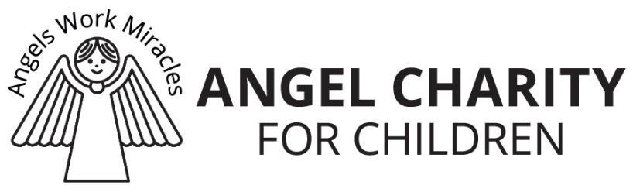
3132 N. SWAN RD. ∙ TUCSON, ARIZONA 85712 ∙ 520-326-3686 ∙ ANGELCHARITY.ORG
Date

Dear XX,

On behalf of Angel Charity for Children, Inc. we would like to thank you for your recent donation.

Your gift, XXXX, is a valuable addition be used in the Silent Auction at our Angel Ball, December 11, 2021. Your generosity dramatically impacts the lives of children in our Tucson Community. This year’s beneficiaries will benefit immensely from your kindness.

As we turn the corner on a new year, we thank you for your continued support of Angel Charity and our mission to serve the children in Pima County. Over the past 39 years, we have raised $28 million for 113 charities, helping over a million children. With your help, we are committed to honoring our mission because our children need us now more than ever.

Angel Charity, like so many, has made adjustments and adapted our fundraising approach with the safety of our community and our members in mind. Our Board of Directors has approved a Two-Year Fundraising Plan, extending the time to fundraise for our beneficiaries and rescheduling our signature in person events for the Fall of 2021. The challenges we have endured have only strengthened our resolve to support the needs of the children in our community as we partner with our donors to fundraise a record setting $1,414,403 for our 2020 and 2021 beneficiaries:

Intermountain Centers - $700,000 to help fund a 60,000 sq. ft. building at 401 N. Bonita, an integrated service campus that provides early intervention therapies for children with complex medical needs. They will have access to primary care physicians, psychiatric services, occupational therapy, crisis intervention and more in this facility.
- Reid Park Zoo - $265,000 towards construction of the “World of Play Adventure Zone” which will be inside the current zoo footprint. It will be modeled after regions of the world and will teach basic science concepts about geographic regions and animals of the world while encouraging nature play, physical activity – and fun!
- 2020 Small Grants - $195,020 for Amanda Hope Rainbow Angels, Boys to Men, Jewish Family &
Children’s Services (JFCS), Literacy Connects and Make Way for Books.
- 2021 Small Grants - $254,383 for Boys & Girls Club of Tucson, Interfaith Community Services, Ronald McDonald House Charities of Southern Arizona, Tu Nidito Children and Family Services and Tucson
Refugee Ministry.

Your support will make a difference in the life of a child and significantly impact the future of our community. Thank you again for your generous donation.

Sincerely,
XXXXXX

